Transitive Verbs

🔹 What is Transitive Verbs
# Source: AI Source: Provided by: [Data Path: Persons Table -> ID Column: 1, Name_En Column: Motasem Essam] -> From: [Chatgpt (GPT-4-turbo)] on [7/27/2025]
A transitive verb is a verb that requires a direct object to complete its meaning. The object receives the action of the verb.

✅ Definition:
# Source: AI Source: Provided by: [Data Path: Persons Table -> ID Column: 1, Name_En Column: Motasem Essam] -> From: [Chatgpt (GPT-4-turbo)] on [7/27/2025]
A transitive verb is a verb that must be followed by a direct object (a noun or pronoun) that receives the action of the verb.

🧠 Ask: "Verb what?" or "Verb whom?"
# Source: AI Source: Provided by: [Data Path: Persons Table -> ID Column: 1, Name_En Column: Motasem Essam] -> From: [Chatgpt (GPT-4-turbo)] on [7/27/2025]
If you can answer the question — the verb is transitive.

📚 Examples in Sentences:
# Source: AI Source: Provided by: [Data Path: Persons Table -> ID Column: 1, Name_En Column: Motasem Essam] -> From: [Chatgpt (GPT-4-turbo)] on [7/27/2025]
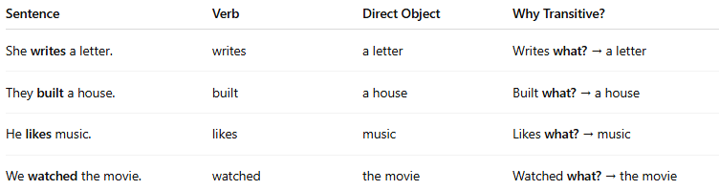
Sentence | Verb | Direct Object | Why Transitive?
She writes a letter. | writes | a letter | Writes what? → a letter
They built a house. | built | a house | Built what? → a house
He likes music. | likes | music | Likes what? → music
We watched the movie. | watched | the movie | Watched what? → the movie

❌ Without an object, it sounds incomplete:
# Source: AI Source: Provided by: [Data Path: Persons Table -> ID Column: 1, Name_En Column: Motasem Essam] -> From: [Chatgpt (GPT-4-turbo)] on [7/27/2025]
- ❌ She writes. (Writes what?)
- ❌ They built. (Built what?)
You expect something after the verb to make sense.

🔁 Transitive vs Intransitive Verbs:
# Source: AI Source: Provided by: [Data Path: Persons Table -> ID Column: 1, Name_En Column: Motasem Essam] -> From: [Chatgpt (GPT-4-turbo)] on [7/27/2025]
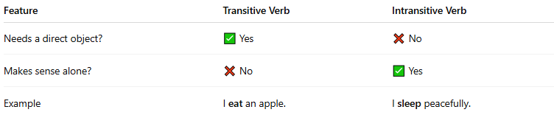
Feature | Transitive Verb | Intransitive Verb
Needs a direct object? | ✅ Yes | ❌ No
Makes sense alone? | ❌ No | ✅ Yes
Example | I eat an apple. | I sleep peacefully.

✅ Summary:
# Source: AI Source: Provided by: [Data Path: Persons Table -> ID Column: 1, Name_En Column: Motasem Essam] -> From: [Chatgpt (GPT-4-turbo)] on [7/27/2025]
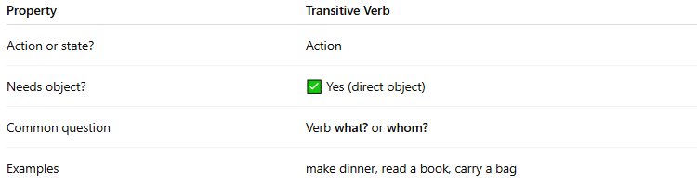
Property | Transitive Verb
Action or state? | Action
Needs object? | ✅ Yes (direct object)
Common question | Verb what? or whom?
Examples | make dinner, read a book, carry a bag

